**SOURCE 1**

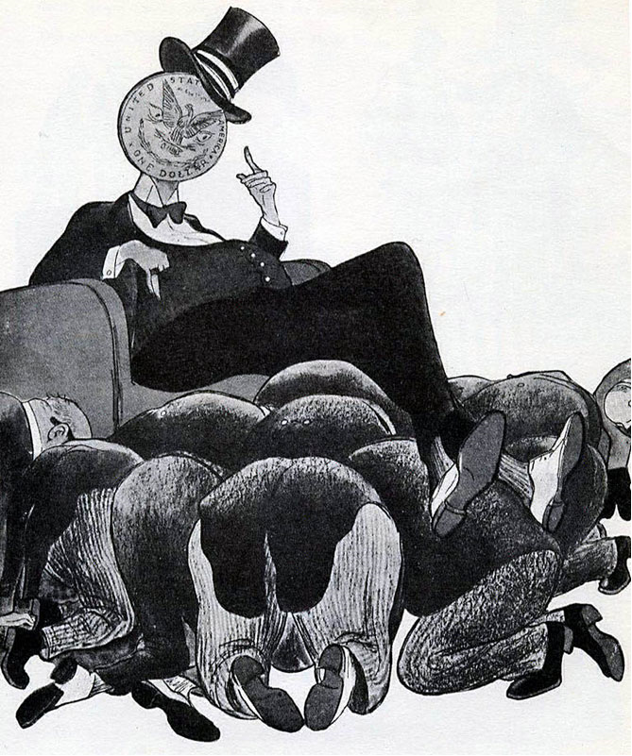

**This cartoon of 1947, from a Soviet magazine, had the caption ‘Capitalist Europe on the Upswing’**

**SOURCE 2**

“The remedy lies in breaking the vicious circle and restoring the confidence of the European people in the economic future of their own countries and of Europe as a whole. …….  Aside from the demoralizing effect on the world at large and the possibilities of disturbances arising as a result of the desperation of the people concerned, the consequences to the economy of the United States should be apparent to all. It is logical that the United States should do whatever it is able to do to assist in the return of normal economic health in the world, without which there can be no political stability and no assured peace. Our policy is directed not against any country or doctrine but against hunger, poverty, desperation and chaos. Its purpose should be the revival of a working economy in the world so as to permit the emergence of political and social conditions in which free institutions can exist. ……… Any government that is willing to assist in the task of recovery will find full co-operation I am sure, on the part of the United States Government. Any government which maneuvers to block the recovery of other countries cannot expect help from us……..”

**A speech by George C. Marshall at Harvard University, 5 June 1947**



**SOURCE 3**

**The McCord Museum is home to an important cartoon collection. More than 10,000 of the works in it were created by John Collins, one of 20th-century Canada's foremost cartoonists. Collins's cartoons were published in the Montreal newspaper, The Gazette, for 40 years.**

**SOURCE 4**

**Communism in Eastern Europe 1945-1948**

| **Country** | **Date** | **Method** |
| --- | --- | --- |
| Albania | 1945 | The Communists immediately took power. |
| Bulgaria | 1945 | In the 1945 elections, a Communist-led coalition was elected, but the Communists executed the non-Communists. |
| East Germany | 1945 | East Germany was the Soviet zone of Germany. In 1949, they set up a Communist-controlled state called the German Democratic Republic. |
| Romania | 1947 | In the 1945 elections, a Communist-led coalition was elected to power. The Communists gradually took over and in 1947 they abolished the monarchy. |
| Poland | 1947 | Stalin had promised to set up a joint Communist/non-Communist government at Yalta, but then he invited 16 non-Communist leaders to Moscow and arrested them. Thousands of non-Communists were arrested, and the Communists won the 1947 election. |
| Hungary | 1947 | The non-communists won the 1945 elections with Zoltan Tildy as president. However, the Communists' leader, Rakosi, took control of the secret police (the AVO), and executed and arrested his opponents. Tildy was forced to resign and Cardinal Mindzenty, head of the Catholic Church, was imprisoned. By 1948, Rakosi had complete control of Hungary. |
| Czechoslovakia | 1948 | A coalition government was set up and led by the non-Communist Benes. However, the Communists' leader Gottwald made sure they controlled the radio, the army and the police. Gottwald became prime minister and set up a secret police force. Non-Communists were arrested. In 1948, Communist workers went on strike, the non-Communist minister Masaryk committed suicide and Gottwald took over the government. |

**GCSE BBC educational website:** [**http://www.bbc.co.uk/schools/gcsebitesize/history/mwh/ir2/sovietexpansionineasterneuroperev2.shtml 2014**](http://www.bbc.co.uk/schools/gcsebitesize/history/mwh/ir2/sovietexpansionineasterneuroperev2.shtml%202014)

*Name: _________________________ Narrogin Senior High School*



**Unit 4, Modern History**

***SOURCE ANALYSIS ONE***

**The Changing European World Since 1945**

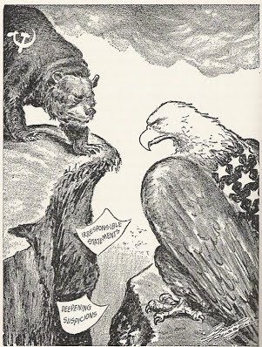

Specific answers will depend on the sources selected by the teacher.

When marking a student’s work:

•not all points necessarily need to be in an answer for the student to gain full marks

•reward each salient point made by the student. Students may make different valid points of interpretation

•students are expected to refer to relevant supporting evidence from the sources.

**Marks out of 25:**

**Weighting: 5 %**

**SECTION ONE: SOURCE ANALYSIS SET 1, Unit 4**

This section has ONE question made up of **FIVE (5)** parts. Attempt **ALL** parts. Write your answers in the spaces provided.

* The marks allocation for this section is 25 marks.
* Allow approximately 45 minutes for this section.

Indicate below the document set from the **Document Booklet** you will use to respond to this

question.

Set 1: □ The changing European world since 1945

Set 2: □ Australia’s engagement with Asia

Set 3: □ The struggle for peace in the Middle East

**Question 1**

1. Explain the historical context of **Source 1**. Include the relevant events, people and ideas depicted or represented in the source. *(3 marks)*

*The historical context of Source 1 (S1) is the Marshall Plan initiated during 1947 by the United States. It was an economic strategy to reduce the likelihood of another economic depression within Europe post World War Two (WWII). Such conditions could lead to a rise in extremist parties as had occurred during the 1930s in Germany with the rise of the Nazi Party. Post WWII, the US and their Western European allies feared the concept of ‘Communisation’ and therefore the Marshall Plan was a form of economic ‘Containment’ of the perceived spread of communism from the Soviet Union; an event that had already seen most of the Eastern European states convert into communist led satellite states of a growing Soviet sphere of influence.*

*The Soviets saw the Marshall Plan as a form of ‘Dollar Imperialism’: the USA ‘buying favour’ in Western Europe to strengthen their own sphere of influence and maintain a healthy US market in Europe – an example of capitalistic greed. This notion was strengthened in the eyes of the Soviet leadership as the overall total of 13 billion dollars presented and distributed to ‘any’ European nation interested in the Marshall Plan, or European Economic Recovery Program as it was also known, came the with the ‘catch’ that those nations’ economies were to be opened to the western capitalist system. In such an event, Eastern European nations, including the USSR, would have to convert their communist system of trade and economics to one of a capitalist nature, effectively ending the ideology of communism within their states – a desire the US greatly intended as the two political systems were of polar opposites. This political and economic atmosphere developed an unhealthy series of competition and rivalry, despite the fact that the two protagonists, the USA and the USSR had been part of the Grand Alliance against Hitler and Nazi Germany during WWII.*

|  |  |
| --- | --- |
| **Description** | **Marks** |
| Identifies the focus of the source | 1 |
| Outlines the causes or event that led to the focus of the source | 1 |
| Provides details of the focus of the source, events/people/ideas/dates/places | 1 |
| **Total** | **3** |
| **Note:** This question is concerned with the historical context in which the source is located. Answers should focus on what is in the source and provide the big ‘picture’ for that source. |  |

**(b)** Compare and contrast the purpose of **Sources 1** and **2.** (6 marks)

*The purpose of Source 1 (S1) is to highlight to the population of the Soviet Union and their communist allies through a presumably popular magazine, the level of greed of the United States and the self-adoration of the influences of capitalism. This is evidenced by the adulation the members of Western Europe are giving, depicted as the worshipping group at the feet of the United States; the main proponent, focus and attraction being the US Dollar. The term ‘Capitalist Europe on the Upswing’ probably refers to the US Marshall Plan, an economic policy to help rebuild Western Europe from 1947. The Soviet leadership termed this as ‘Dollar Imperialism’ – winning favour and influence. This cartoon certainly highlights that view, witnessed by the captivated and subservient attitude of the throng of European leaders seen at the feet of a wealthy America.*

*The purpose of Source 2 (S2) is for the architect of the Marshall Plan, the US Secretary of State, George C. Marshall, to explain and justify the reasons and the need for American economic assistance in Europe during 1947. This extract from his speech acknowledges that economic support for Europe would indeed benefit the economy of the US in the long run, but he emphasises the humanitarian aim as the primary reason. The speech here comes with an open invitation to those who desire assistance, but it also comes with a clear warning to those nations who may attempt to block or hinder this ‘humanitarian initiative. Presumably this part of the speech is to inform the American public of US foreign policy in relation to Europe.*

*The similarities of purpose between S1 and S2 are that they both aim to inform or highlight the intended reason behind the Marshall Plan of 1947. Each source has an agenda of persuading the public about a particular aspect of the plan, though these agendas differ.*

*S1 and S2 differ in purpose in that S1 is a form of Soviet propaganda, accusing the US of using the dollar to gain more popularity in a selfish, self-propelling manner. The purpose of S1’s use is to establish the sinister aspect of foreign US policy and the use of the dollar to promote themselves. On the contrary, S2 is a US government attempt to highlight that the Marshall Plan is largely an unselfish act and is to benefit others, and in doing so, promote peace and prosperity for all. The purpose of each source contradicts one another in terms of the aims of US foreign policy.*

*S1 mentions capitalism specifically in the text and makes a literal reference to the United States on the coin depicted, indicating that its purpose is a direct accusation to the US. S2 only refers to other countries in general terms, electing to not name the Soviet Union directly (though it could be construed as being inferred). No mention of capitalism or communism appears anywhere in S2, so its purpose is less direct in terms of propaganda, yet this intention is veiled.*

|  |  |
| --- | --- |
| **Description** | **Marks** |
| Identifies the purpose of the Source 1 | 1 |
| Identifies the purpose of the Source 2 | 1 |
| Identifies elements of comparison between the two sources | 1-2 |
| Identifies elements of contrast between the two sources | 1-2 |
| **Total** | **6** |
| **Note: This question focuses on the reasons for the construction of the sources, and what they aim to achieve. Answers should identify the issue/event/subject of each source; identify the message of the sources; identify the likely purpose for which the source was constructed (or, in the case of the photograph, how the source might have been used, which might produce variations in student interpretation. The response should use evidence from the source to support the response. Lastly, the response should** **explain how they compare (are similar) and contrast (are different) in terms of their purpose.** |  |

**(c)** Identify and explain the message/s of **Source 3**. (3 marks)

*The message of Source 3 (S3) is that after WWII the world should have been enjoying a period of peace and prosperity; to enjoy the finer things in life after a period of conflict, much like a child may deserve an ice cream as a treat, as evidenced in the source. Yet the plans of a united world (symbolised as the one head of a child), under what became the newly formed United Nations, was increasingly being affected by the growing concerns and issues manifesting themselves in a new form of conflict – the Cold War, symbolised by the growing yet melting ice cream, ready to spoil the look or feelings of the holder, meaning the world’s nations and their people.*

*The caption ‘Not a very healthy diet’ alludes to the prospects for the future as the competition and rivalry between the Capitalist West and the Communist East during the five years post WWII, had the potential of leading the world into another, more terrible conflict. The Cold War, epitomised by everything short of direct conflict between the USA and the USSR with their respective allies, always held the possibility of becoming a ‘Hot War’. This potential change in the nature of foreign relations is hinted at in the cartoon with the melting aspect of the overloaded ice cream – a situation difficult to manage and control, much like the balancing act seen in the image.*

|  |  |
| --- | --- |
| **Description** | **Marks** |
| Explain the message of the source | 3 |
| Outlines the message of the source | 2 |
| Identifies an aspect of the message of the source | 1 |
| **Total** | **3** |
| **Note: Look for the message conveyed by the source. Answers should: consider all of the elements of the source: title/ author/ date/ location; identify the issue/ event/ subject; identify the representation or opinion being expressed; provide evidence from the source to support the response.** |  |

**d)** Identify how and discuss why **Source 3** and **4** are contestable. (6 marks)

*Source 3 (S3) is contestable in that it portrays the message that the ‘Cold War cone’, or issues deriving from the situation, are manageable by the world that appears in the image as one entity, when in fact the world was becoming more bipolar within that 5 year period following WWII, when the US and the USSR and their respective allies created political, economic and military division. This aspect is not emphasised in the image indicating that the source fails to express the full and complicated nature of the situation. The cartoon also hints that there was a clear 5 year plan for the world post WWII, when in reality the superpowers at that time could not even agree on what to do with a vanquished Germany, never mind how to steer the global political climate to peace.*

*Source 4 (S4) is contestable in that it is statistical in nature regarding the progression of events in years and although it presents some information about how communist governments emerged or were formed in Eastern Europe post WWII, it does not go so far as to identify why those events took place.*

*S4 is from a western viewpoint and harbours elements of criticism and accusation regarding the nature of what they termed as ‘communising Europe’. S4 fails to give any perspective from the eastern bloc, who presumably could offer some justification for these on-going events in terms of creating friendly, politically aligned governments. It is well known amongst many historians today that an alternative version of history was that the Soviets desired to create a ‘buffer zone’ alongside their borders to prevent what they often perceived as western aggression. This element of perspective is not evidenced in S4 and therefore makes its nature and intent questionable.*

|  |  |
| --- | --- |
| **Description** | **Marks** |
| Identifies the element/s of contestability for Sources 3 and 4 | 1–2 |
| Discusses the reasons for the contestability of Source 3 | 1–2 |
| Discusses the reasons for the contestability of Source 4 | 1–2 |
| **Total** | **6** |
| Note: The concept of contestability requires a discussion of conflicting historical interpretations represented in source material, specifically why they are different and open to debate. Answers should demonstrate an understanding of what can make a source contestable, whether it provides a certain interpretation of events for which other interpretations exist; or whether the source/s can be disputed as historical evidence. Identify in each source the argument/s, biases, motives or perspectives that can be disputed. Stronger candidates may discuss the nature of the contestability, perhaps by referring to alternative arguments or viewpoints on the interpretations presented by the sources, or by making comparisons between the two sources. |  |

**(e)** Using your knowledge of the whole period of study, evaluate the importance of the

idea of foreign policy represented in the four sources. (7 marks)

*The four sources present elements of the differing foreign policies of the two superpowers that emerged after WWII, the US and the USSR. Each superpower held opposing political ideological views and combined with historical mistrust that had developed since the Bolshevik Revolution of 1917, a negative relationship of suspicion and fear continued to grow. Each superpower and their respective allies feared that their opponents were intent on destroying the fabric of their own political, economic and social systems. Although many of the nations involved had been close allies fighting against the Nazis, by 1945 the power vacuum left by a defeated Germany was quickly filled by the USA and the USSR in a bid to extend their spheres of influence.*

*The West feared the spread of communism from the Soviet Union and witnessed the steady political conversion of all of Eastern Europe from the mid to late 1940s, as described within S4. The US and their western allies recognised that the situation was too late to reverse, short of going into another bloody conflict, as the notion of communisation had already occurred. The US therefore adopted a foreign policy of containment, to stem and stop any further westward communisation of Europe. This entailed, in part, an economic plan to inject $13 billion into European nations to strengthen hastenen economic recovery. The architect of this was George C. Marshall. An excerpt of his speech is highlighted within S2. The US’ aim was to avoid another economic depression that was likely to become a breeding ground for extreme parties, namely communism. As a form of containment, this was effective, as many European nations accepted this aid and remained capitalistic in nature. There was also the added benefit of maintaining an economic market for the US in Europe.*

*The Soviet perspective on the Marshall Plan was that it was a US ploy to further their imperialistic growth globally by ‘buying’ the loyalty of European nations. A term that the Soviet leadership used was ‘Dollar Imperialism’, hence the nature and message portrayed and visualised in S1. These conflicting perspectives are typical of the period as the mutual mistrust and fear often led to a sense of suspicion of whatever the other side was doing. Each bloc, both East and West, continually saw something sinister and insidious in everything that their counterparts did. The West could not accept that the Soviet strategy of communising Eastern Europe was defensive in nature. Instead, the US simply saw one tyrant, the Soviet Union, replacing another, Nazi Germany. This notion explains why S4 fails to acknowledge the Soviet version of a buffer zone of politically friendly neighbours in Eastern Europe.*

*This period commonly became known as ‘The Cold War’ as neither side was willing to plunge the world into another global conflict, yet the potential of war was ever present because of the rivalry. Most people were anticipating a prolonged period of peace and prosperity after the six years of WWII. This hope was all too evident in the formation of the United Nations. S3 is a visual representation of how this atmosphere soon soured and the tense political atmosphere instigated by the competition between the superpowers forecast a darker challenge for Europe and the world. As the two sides initiated their respective foreign policies and solidified their spheres of influence, the competition and rivalry gathered at pace. As one side took the initiative, the other was compelled to respond. Reaction followed action and the tense atmosphere escalated in a series of crises and examples of brinkmanship.*

*By 1950, crisis piled on crisis as reflected in S3, Europe was clearly divided east to west along political lines. Germany was the centre of this division, on which neither side could agree. Accusations and disagreement heightened the tension. Agreements made at the Potsdam Conference during 1945 were disregarded. The Soviets tried to pressure the West out of Berlin during a blockade that lasted 11 months during 1948/49. The West refused to budge and initiated an airlift of supplies. Military alliances were established; the West created NATO; the East developed the Warsaw Pact, each seen to be aggressive in nature, yet announced to be defensive. Propaganda and economics became the primary tools for each side of the Cold War as a balance of power, or balance of terror in the form of atomic and nuclear weapons, made the prospect of a ‘hot war’ MAD (Mutually Assured Destruction).*

|  |  |
| --- | --- |
| **Description** | **Marks** |
| Identification of the themes/ ideas/ events | 1 |
| Placement of the themes/ ideas/ events with the themes/ ideas/ events of the broader historical context of the time. Students should be able to demonstrate a breadth and depth of the time period. | 1–2 |
| Evaluation of the themes/ ideas/ events in relation to those of the broader context. | 1–2 |
| Compare and/or contrast with what is in the sources with the other themes/ ideas/ events within the time period. | 1–2 |
| **Total** | **7** |
| Note: This question does not require reiteration of the messages in the sources.  Evaluate the importance of the theme/idea/event in relation to how they are represented in the sources; relates to the other themes/ideas/events of the whole period.  Answers should identify the themes/ideas/events in the sources; evaluate the importance of what is shown in the sources by using evidence from the sources and the whole historical period; refer to the long-term and/or short-term effects of the theme/idea/event; refer to elements of continuity and/or change evident in the theme/idea/event; demonstrate a depth and breadth of knowledge for the whole time period. |  |